System Design
Requirement

https://writer.zoho.in/writer/open/44fzxca4cc9056a3a45f0b456d530f716fddd
This link contains the entire documentation on both Functional and Non-functional Requirement.
use case:
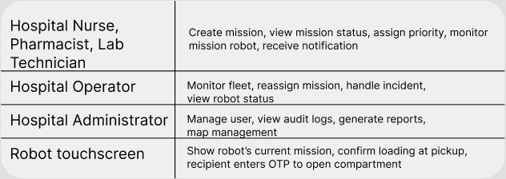
Clients and interfaces -> Who communicates with my system, and how do they communicate with it?
Clients
Hospital Web Dashboard - Monitor robots, create missions, view reports
Nurse Mobile UI - Mission creation, Track orders
Administrator - User management, audit
Robot/fleet System - Send robot state and receives commands

Interface
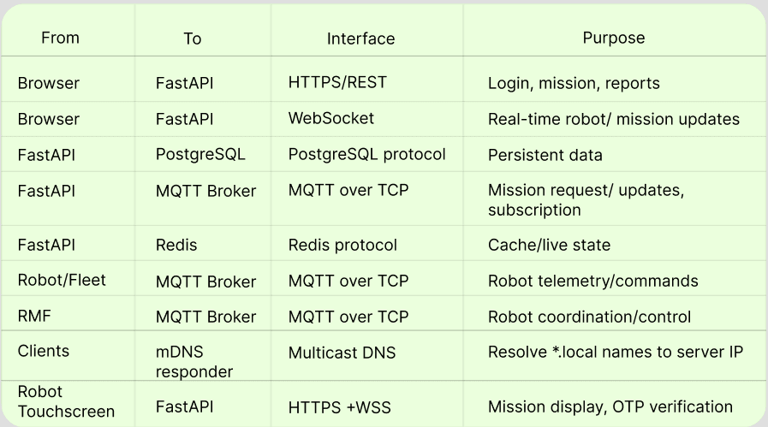
Interface flow
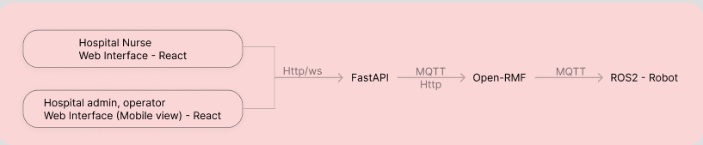

High-Level Architecture
https://www.figma.com/design/wP5LvFIKbb7SGEeq8SyPIe/system-design?node-id=1-3&t=6kwklZCkf2AKiEHQ-1
This is the link of the System architecture in figma. For Reference
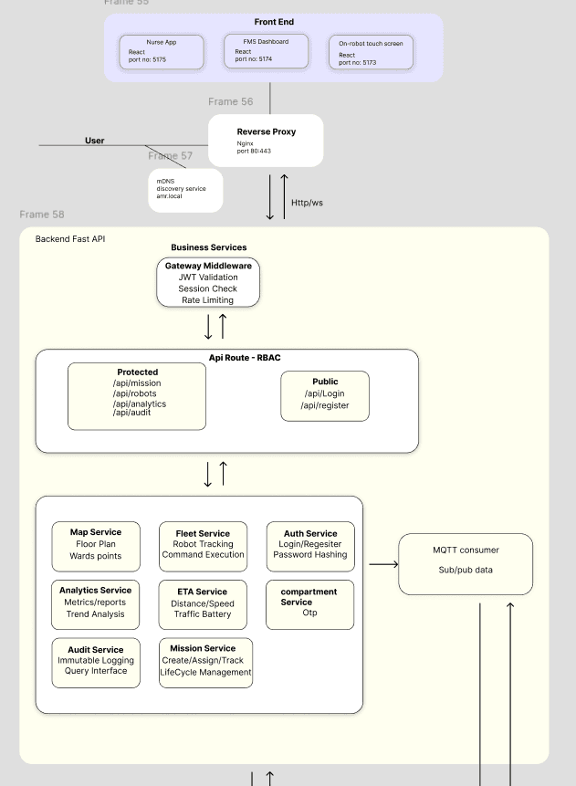
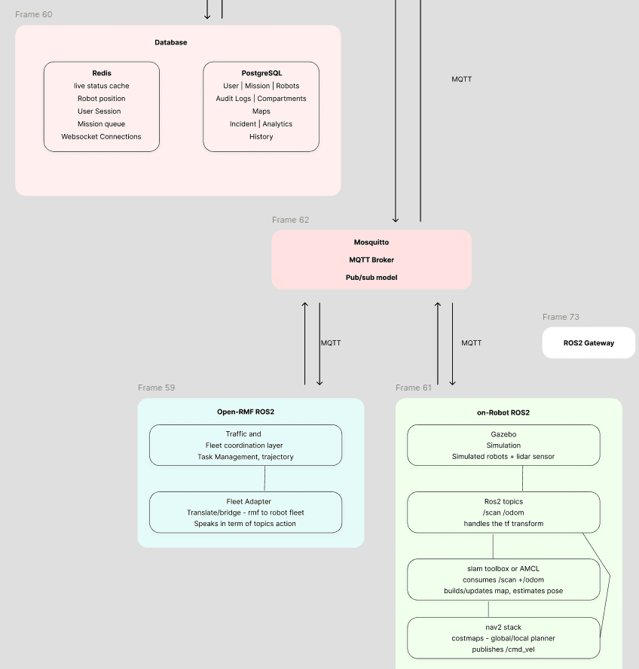

Components
What is Reverse proxy? -> A reverse proxy is an intermediary server that sits in front of one or more backend web servers, intercepting all incoming client requests.
why Reverse Proxy ->
- Load Balancing: Distributes incoming traffic across multiple services (using round-robin, least connections, etc.) or to prevent any single server from becoming a bottleneck.
- Security & Anonymity: Hides the actual IP addresses and internal topology of your backend servers. External clients only ever interact with the reverse proxy IP.
- SSL/TLS Termination: Offloads the CPU-heavy task of decrypting HTTPS requests. The proxy handles SSL termination with clients and forwards plain HTTP (or lightweight secure traffic) internally over a private network.
- Routing & Path Mapping (API Gateway): Routes traffic based on paths or headers. For example:
  - [api.example.com/v1/users](https://api.example.com/v1/users) -> User Microservice
  - [api.example.com/v1/telemetry](https://api.example.com/v1/telemetry) -> WebSocket Ingestion Cluster
- Rate Limiting & Protection: Prevents DDoS attacks and abuse by throttling requests before they reach core application logic.
- Provide a single entry point for the frontend applications and backend APIs. Serve React frontend application, forward websocket upgrade requests to FastAPI Websocket endpoint.
Local DNS and service discovery
Responsibilities:
- Allow hospital devices to resolve the application hostname to the appropriate server IP address.
- Support access to the system over the hospital's local network.
- Avoid requiring public internet access for normal system operation.
but in actual production we use hospital network if it provides internal DNS.
FastAPI backend components
The FastAPI backend contains the system's application logic and provides the interface between the frontend, databases, and robot coordination infrastructure.
GateWay Middleware->
- Process incoming HTTP requests.
- Validate authentication credentials.
- Apply authorisation checks and rate limits.
- Enforce appropriate request validation and security controls.
- Apply consistent error handling and request logging.
For protected operations, the backend validates the user's JWT and checks the permissions associated with their role.
API Routes and RBAC
The API layer exposes the backend functionality to the frontend.
Public and protected routes
Responsibilities:
- Receive and validate client requests.
- Pass requests to the appropriate business service.
- Return structured responses.
- Enforce role-based access control (RBAC).
- Apply permissions to sensitive operations like create delivery mission, view audit records.

Authentication Service
Responsibilities:
- Authenticate users against the user database.
- Register users where permitted.
- Verify password hashes.
- Issue JWTs after successful authentication.
- Validate session credentials.
- Support logout and token-expiration handling.
- Provide user roles and permissions to the authorisation layer.
When the session expires, the backend should close the connection, and the frontend should redirect the user to log in again.

Mission Service
Responsibilities:
- Create mission records.
- Record mission status and lifecycle changes.
- Submit valid mission requests to the robot coordination layer.
- Track mission progress and outcomes.
- Handle cancellations and failures according to the system's rules.
- Maintain the association between missions, robots, and payloads.
;
Communication:
- Receives mission requests from the API layer.
- Stores mission records in PostgreSQL.
- Submits task requests to Open-RMF through the defined integration.
- Receives mission status updates from the robot coordination infrastructure.
- Publishes relevant updates to connected frontend clients.

Analytics Service
Responsibilities:
- Calculate deliveries per day.
- Calculate average mission duration.
- Calculate mission success and failure rates.
- Summarise robot utilisation.
- Analyse battery usage.
- Produce date-filtered operational reports.
- Provide data for dashboard charts and summaries.
Communication:
- Reads historical mission and robot records from PostgreSQL.
- Receives data requests from the API layer.
- Returns aggregated results to the FMS Dashboard.

Compartment Service
Responsibilities:
- Manage compartment metadata.
- Associate compartments with robots and delivery missions.
- Track compartment availability and delivery-access state.
- Validate compartment-access requests.
- Generate or validate OTPs if OTP-based access is required.
- Record successful and unsuccessful access attempts.
Communication:
- Receives requests from authorised frontend interfaces.
- Reads and updates relevant records in PostgreSQL.
- Uses Redis for temporary OTP state or expiry tracking where appropriate.
- Sends access commands through the defined robot integration.
OTPs should expire, have attempt limits, and be associated with the relevant delivery or access request. Compartment release must require appropriate backend authorisation.

Audit Service
Responsibilities:
- Record important user actions.
- Record mission creation, assignment, cancellation, and completion events.
- Record compartment-access attempts.
- Record administrative changes.
- Support filtering and retrieval of audit records.
- Provide audit data for authorised users.

Mosquitto MQTT Broker
Technology: Eclipse Mosquitto
Purpose: Provide the MQTT message broker used for communication between the backend integration, Open-RMF integration, and robot-side components.
Responsibilities:
- Accept MQTT client connections.
- Receive published messages.
- Route messages to subscribers based on topic subscriptions.
- Apply configured authentication and access-control rules.
- Support configured MQTT Quality of Service (QoS) levels.
- Manage client sessions according to broker configuration.
example: hospital/robot/robot_01/telemetry
MQTT Consumer / Publisher Integration
This component connects the application to MQTT and processes relevant messages.
Responsibilities:
- Subscribe to required MQTT topics.
- Receive robot telemetry and status messages.
- Validate message structure and identify the originating robot.
- Update live robot state in Redis.
- Persist important events to PostgreSQL when required.
- Pass relevant information to the appropriate backend services.
- Publish application commands when required by the defined integration.
the integration may need to perform both subscribing and publishing.
MQTT message reliability
- QoS 0: Suitable for some high-frequency updates where occasional loss is acceptable.
- QoS 1: Suitable when delivery at least once is required, provided consumers handle duplicate messages.
- QoS 2: Provides stronger MQTT delivery guarantees, but it does not by itself guarantee that the business operation was completed exactly once.
command identifiers, acknowledgements, timeouts, and idempotent processing,receiving the same compartment-release command twice should not result in an unsafe repeated action,
Open-RMF:-> fleet/task/traffic coordination layer.
It helps multiple robots share a facility and coordinate their movement and tasks.Open-RMF provides the robot fleet coordination and task-management layer.
Responsibilities:
- Coordinate robot traffic.
- Manage traffic schedules and planned trajectories.
- Coordinate access to shared lanes and constrained spaces.
- Support fleet-level task allocation and execution through the configured task-management interfaces.
- Handle traffic conflicts and replanning within the supported integration.
- Coordinate participating fleets across the facility.
Open-RMF uses information from fleet adapters and other configured components to coordinate robot movement.

Open-RMF Task Management
Responsibilities:
- Accept supported task requests.
- Manage task assignment and execution through the configured RMF task-management infrastructure.
- Track task progress.
- Coordinate tasks with fleet capabilities and availability.
- Support task interruption and failure handling through the relevant integration.

Edge Case: A robot encounters a person standing in front of it. RMF does not need to receive the robot's entire LIDAR/Costmap. Robots local navigation stack handles that situation.
RMF handles the fleet-level problem.
NAV2 :-> handles individual robot navigation.( goal-> planner -> controller -> velocity commands -> robot )
It deals with: Localization, costmaps, planners, controllers. obstacle avoidance, sensor data.

Fleet Adapter
Purpose: Integrate a robot fleet with Open-RMF.
Responsibilities:
- Report fleet and robot state to Open-RMF.
- Translate between robot-specific state and RMF representations.
- Receive relevant commands or task instructions from RMF.
- Communicate with the robot's control interface.
- Report execution progress and interruptions.
- Provide the information RMF requires to coordinate robot traffic.
The fleet adapter is an important integration component for connecting a fleet to Open-RMF.
RMF MQTT Integration
This requires an explicit integration component that translates between MQTT messages and Open-RMF's ROS 2 interfaces.
Responsibilities:
- Receive relevant MQTT messages.
- Translate robot state and other supported messages into the appropriate RMF-facing representations.
- Forward commands or other relevant data through MQTT.
- Associate messages with the correct robot.
- Handle disconnections and reconnections.
- Report communication failures to the appropriate components.
This integration is not automatically provided merely by installing Mosquitto or Open-RMF. You must implement or configure an MQTT adapter or bridge that supports the message formats and behaviour required by your system.

Gazebo Simulation
Technology: Gazebo Harmonic
Responsibilities:
- Simulate the hospital environment.
- Simulate robot models and movement.
- Simulate sensors, including LiDAR.
- Provide simulated sensor readings and physical state.
- Support testing without requiring real robots.

ROS 2 Topics and Transform System
Technology: ROS 2 Jazzy
Responsibilities:
- Exchange messages between ROS 2 nodes.
- Publish and subscribe to sensor data and robot state.
- Provide odometry and transform information.
- Support communication between localisation, planning, and control components.

SLAM Toolbox or AMCL
Your diagram shows SLAM Toolbox or AMCL.
These are alternatives for different operational stages, not two interchangeable components that must always run together.
SLAM Toolbox:
- Uses sensor observations and motion estimates to construct or update a map.
- Estimates the robot's pose while mapping.
- Supports creating the initial navigation map.
AMCL:
- Estimates the robot's position on an existing map.
- Uses sensor measurements and motion information to update the pose estimate.
- Is commonly used after a map has been created.

Nav2 Navigation Stack
Technology: ROS 2 Nav2
Responsibilities:
- Plan robot movement toward a local goal.
- Maintain and use global and local costmaps.
- Generate and follow navigation trajectories.
- Control the robot's movement.
- React to detected obstacles.
- Report navigation progress and failures.
subsystem of Nav2
global planner-> computes a route toward the goal using navigation map and global costmap
controller-> produces movement commands to follow planned route
global costmap-> represents obstacle and traversal costs over broader planning area
local costmap-> represents nearby obstacle and local traversal cost for movement control
WebSocket service
Responsibilities:
- Establish authenticated WebSocket connections.
- Maintain active connections per FastAPI worker.
- Send live robot positions and mission updates to subscribed clients.
- Route notifications to the relevant frontend interfaces.
- Filter messages according to the client's subscriptions and permissions.
- Detect disconnects and clean up connection state.
- Support reconnection after temporary network failures.

Fleet Service
Responsibilities:
- Provide the frontend with robot status information.
- Track robot availability, position, battery state, and connectivity.
- Associate robot telemetry with the correct robot.
- Provide robot information to the Mission Service when required.
- Publish fleet updates to the WebSocket layer.
- Identify stale telemetry and report robots whose status cannot be confirmed.

Map Service
Responsibilities:
- Provide hospital floor-plan information to the frontend.
- Maintain references to floor plans and navigation-map files.
- Provide map and waypoint metadata.
- Associate robots and missions with the appropriate floor.
- Support the display of robot positions on the hospital map.
- Provide map-related information required by authorised users.
Dependencies: Stored map files, PostgreSQL metadata, Open-RMF map information, and robot-position data.
PostgreSQL with TimescaleDB, provided your deployment environment supports it.
You can keep users, missions, compartments, audit records, and other relational data in PostgreSQL while storing high-volume telemetry in a TimescaleDB hypertable.
A hypertable automatically organises time-series data into time-based chunks, making time-range queries and retention management easier.

How much telemetry could you generate?
The volume depends on your update rate.
For example:
- Five robots sending two telemetry messages per second each produce 10 messages per second.
- Five robots sending 10 telemetry messages per second each produce 50 messages per second.
At 10 messages per second across the entire fleet, that is approximately 864,000 records per day, or 315 million records over 365 days if the rate remains constant.
At 50 messages per second, the volume increases to approximately 4.32 million records per day.
How to send a notification to a particular nurse?
a nurse creaes delivery mission and should be notified when it is completed.The key is to associate each notification with the correct recipient and deliver it only to authorised clients.Suppose nurse U101 creates mission M501.Your mission record should retain the creator's user ID.If the robot completes mission M501, the backend can look up the mission and determine that U101 should receive a completion notification.
The notification is associated with U101, not with every nurse currently connected to the system.
same goes for the recepiant where the db will have a recipients ID.
responsibilities
- Receive notification-triggering events from the Mission Service, MQTT processing, or other relevant backend components.
- Determine the intended recipient using the mission, user assignment, event type, and notification rules.
- Create a persistent notification record in PostgreSQL.
- Ask the WebSocket Manager to deliver the notification to the relevant user.
- Track whether the notification has been read.
- Make unread notifications available through an HTTP API when the user reconnects.
database and caching components

PostgreSQL — application database
Stores:
- Users and roles.
- Mission records and history.
- Robot metadata.
- Compartment records.
- Audit logs.
- Notifications and read status.
- Incident records.
- Map metadata.

4.2 TimescaleDB — telemetry storage
Use a PostgreSQL database with the TimescaleDB extension for high-volume historical telemetry.
Stores:
- Historical robot positions.
- Battery readings.
- Velocity measurements.
- Timestamped robot-state observations.
- Other historical sensor or operational measurements that need time-based queries.
You can keep these records in a dedicated telemetry table or set of hypertables.

4.3 Redis — caching and temporary state
Stores or supports:
- Latest robot positions and status.
- Cached live telemetry.
- Rate-limiting counters.
- Temporary session-related state, if needed.
- Cross-worker notification events, if you later introduce multiple workers.
- Other short-lived application state.

Frontend Architecture Structure
Technology : React
Communication:
HTTP/HTTPS for API requests,login, mission creation
Websocket fro real-time mission updates, robot status and notifications
3 levels of data
- Local component data (eg: deliveries for last 30 days)
- Feature data (eg: fleet -> robotMap, robotCard, robotList)
- shared application data (Robot live state -> needed in both fleet and mission feature)

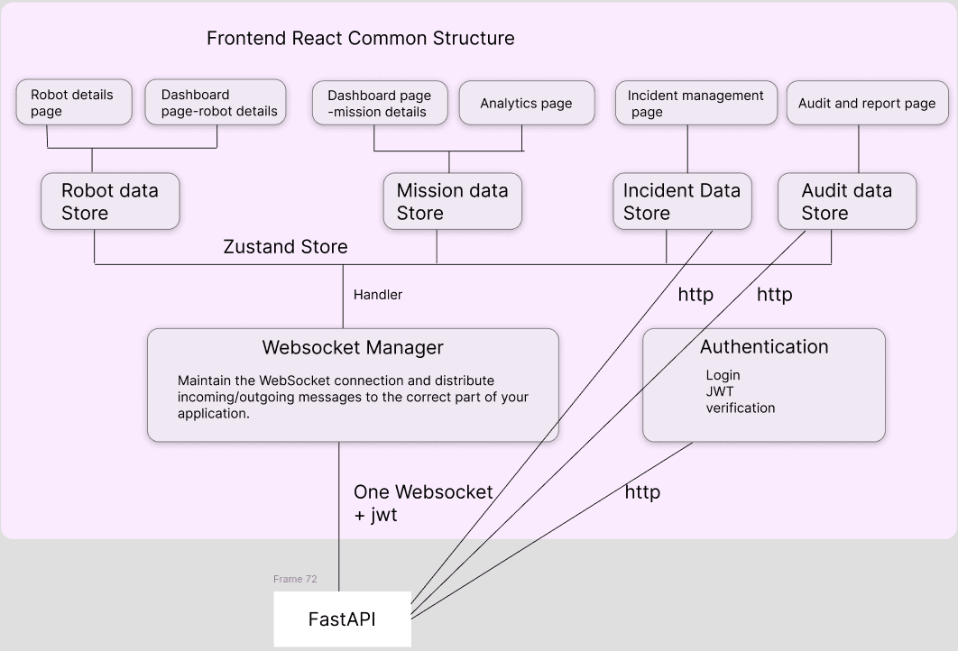
Why Websocket manager?
-> Maintain the WebSocket connection (automatic reconnection) and distribute incoming/outgoing messages to the correct part of your application and other pages wont know about websocket.

problems solved with websocket manager
-> multiple connection, multiple message handler, reconnection code repeated, each page needs to understand websocket messages, difficult to maintain.
We use type in the websocket message protocol, so the websocket can handle it using a handler and store in the respective data store using Zustand store method.
what is zustand? -> library that helps us create shared state in react. Because a normal state belongs to that particular component. It acts as the shared current-state storage and normally we have to manually find the pages and give them the data with this we just store it as a object and it can be used by any other pages.
Why Handler in websocket Manager -> it separates the message and routes it to the correct zustand store.
HttpOnly Cookie for storing the jwt token -
FastAPI -> Set-Cookie: JWT -> Browser stores cookie -> React requests -> Browser automatically sends cookie -> FastApi
This helps prevent JavaScript from directly accessing the token but why -> Because of XSS (Cross-Site Scripting).Imagine your application accidentally has a vulnerability and malicious JavaScript gets executed on your page.
Const token = localStorage.getItem("token");// if JWT is in localStorage.
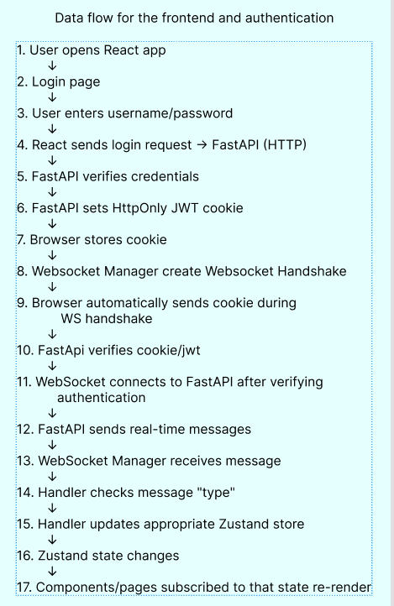
Note: websocket authentication/ session lifecycle have to be explicitly designed because the websocket does not automatically know that the JWT has expired.

Server-side policy for JWT/Session handling for expiration and websocket closing
for horizontal scaling the redis should maintain every current state and that will be used by multiple machine and updated concurrently on redis and frontend.
Reconnection Data flow
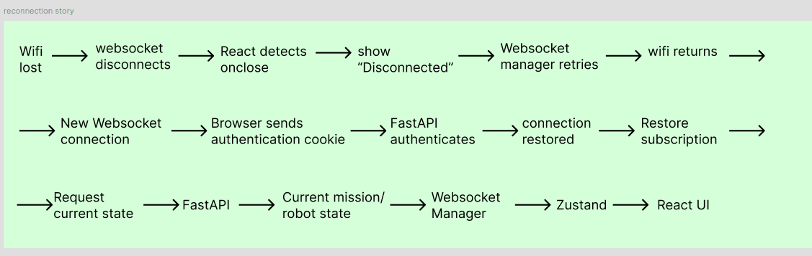

Robot & Simulation Layer — ROS2 Jazzy + Gazebo Harmonic

need to make

Sequential Diagram
1)Initial page loading
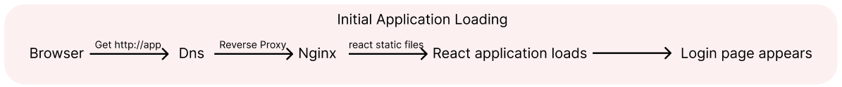
how nginx serves the index file-> we configure and it points to the build directory and serves the file to the browser. when browser requests, nignx serves index.html from the configured directory.the browser reads and discovers which js and css files it needs. the browser again request files from nginx.Nginx delivers the files, but React executes in the browser
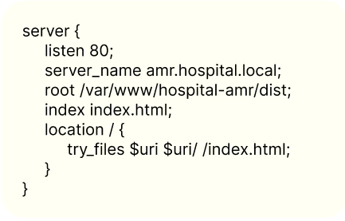

2). Login Flow
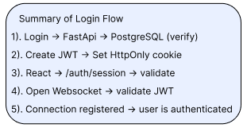
why seperate auth/session request right after login is cause the yser may reload or comes back to the home page after the jwt expire or reopening the application. so it is better to have auth/session get user data and verify jwt rather than getting user info from the the login response.
why sperate authenticate for websocket connection-> Because HTTP authentication and WebSocket authentication are separate connection events. and for the websocket reconnection or sometimes websocket connection might alone gets disconnected.
The cookie must be configured correctly for the WebSocket URL. Also, WebSockets don't use ordinary CORS preflight in the same way as fetch() requests, so explicit Origin validation is important.
what if uesr a is logged in and suddenly admin changed the role of the user a. how to refelet in an existing jwt before expiration? and lets say someone from admin is demoted to operator and he is already logged in now he should not be able to access admin privilage. sol:-> we could get the changed user role and check with the redis if they are active and delete the user ssession in redis, postregresql, websocket manager and ake the user login again.
why we authorize every websocket request-> The frontend must not be able to bypass authorization simply by requesting a topic name.
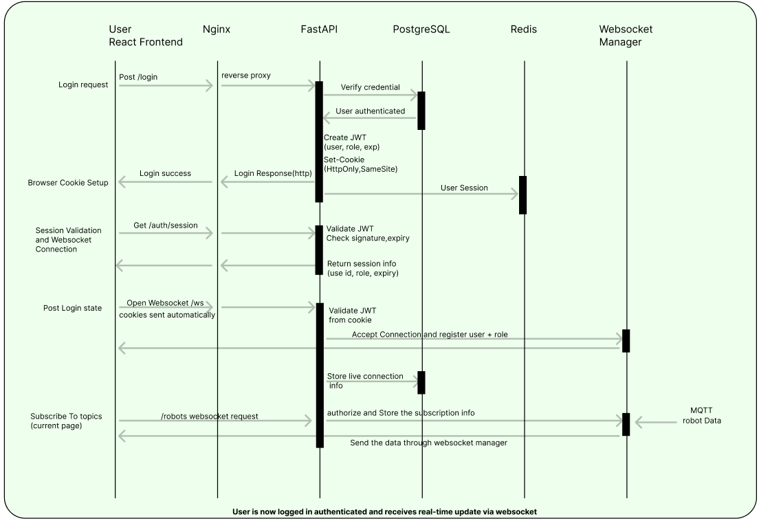
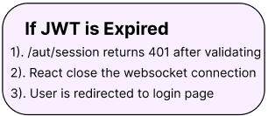
Create Mission
Use idempotency or duplicate-request protection to prevent accidental duplicate missions. So user can create only one mission and can request another after receiving appropriate response for it.
Store the mission in PostgreSQL so the record survives a backend restart or rmf crach.
what happens when rmf crahes -> saving the queue in postgre survive crash but it does not reflect what happened to the robots during the crash. the robot might be stuck, finished the current task, therefore we need to recover actual execution state, not just last saved db status, so we can obtain urrent robot state and poses and reconsile with postgresql mission records after reconnection of rmf. preserve mission records in postgresql ana a accepted/ recjected satte from rmf-> get info from robot after reconnection-> reconcile mission, FastAPI compares PostgreSQL's records with the recovered RMF and robot state. eg - mission(moo1)- db says (in progress)- recovered reality(robot confirms completion)- action(mark completed after verification) -> restore the queue safly(Submit missions that are still pending and have not already been accepted., Do not rerun completed missions., Recover interrupted missions according to the robot's actual state and mission policy., Do not automatically resume an in-progress medicine delivery without checking whether the robot and task can safely continue.).here FastAPI acts as the durable mission record and recovery coordinator, not as a second robot execution queue.
FastAPI crashes before recording the acknowledgement.
FastAPI restarts and attempts to submit M001 again.
Assign a unique application-level mission_id.
- Store the mission in PostgreSQL before submitting it to RMF.
- Track the RMF task ID and submission state when available.
- Use a durable submission record or transactional outbox to ensure pending submissions are not lost if FastAPI crashes.
- Use idempotency or duplicate detection where your RMF integration supports it.
- Reconcile uncertain submissions against recovered RMF and robot state before retrying.
Redis can be configured for persistence, but PostgreSQL is a suitable durable source of truth for your application's mission records.
Also, Redis alone does not solve RMF recovery. You still need to know whether each mission was accepted, whether it was completed, and what the robot was doing when the failure occurred.
For a real hospital deployment, recovery should also define what happens if robot state cannot be verified: the system should fail safely rather than automatically dispatching uncertain missions.
for rmf detection we could publiah a seperate message for its availability.
lets assume robo1 is delivering medicine to ward a and robo2 has pending task to collect a lab sample.open rmf crashes.robot 1 may still be moving, may stop, or may finish its delivery. Robot 2 may be waiting for its task to be dispatched. recovery system must handle these situations differently.
Run the RMF processes under a service manager, such as systemd or Docker with a restart policy.
Have a monitoring component check whether the required RMF services are responsive. periodic verification.
pending state -> Check whether it was submitted or accepted before the crash. Submit only if it was not already accepted.
in progress-> Check RMF and robot state before deciding whether to resume, reassign, or restart.
completed -> Keep it completed; do not resubmit.
submission unknown-> Reconcile before retrying to avoid creating a duplicate task.
mission db
missions
--------
mission_id
robot_id
pickup_location
destination
mission_status
submission_status
rmf_task_id
created_at
updated_at
last_confirmed_robot_state
mission status-> pending, in progress, completed, failed, cancelled, recovery required
submssion statys-> not subnitted, submitted, accepted, reejctedm, submission unknown
rmf failure during ongoing mission
Scenario A: RMF crashes, but Nav2 continues moving-> consider traffic conflicts, doors, lifts, shared corridors, and other robots.
Scenario B: RMF crashes, but the robot completes its task-> reconcile with recoverd data from postgre and robot.
How should you handle an ongoing mission when RMF recovers?
check for healthy reconnection, obtain each robots actual state, compare postgresql, rmf recovered task state, actual robot state
recovered situation ----- recommended action
robot has completed delivery- verify completion and mark mission completed
rmf confirms tsak is still active- reconcile task with robot and continue if safe
robot is stopped partway through task - determine whether original task can safely resume
robot is disconnected - wait for for reconnection and state verification
task subission outcome is unknown - check whether task was accepted before ertrying
task cannot be resumed safely - make it recovery required and sue controlled recovery procedure 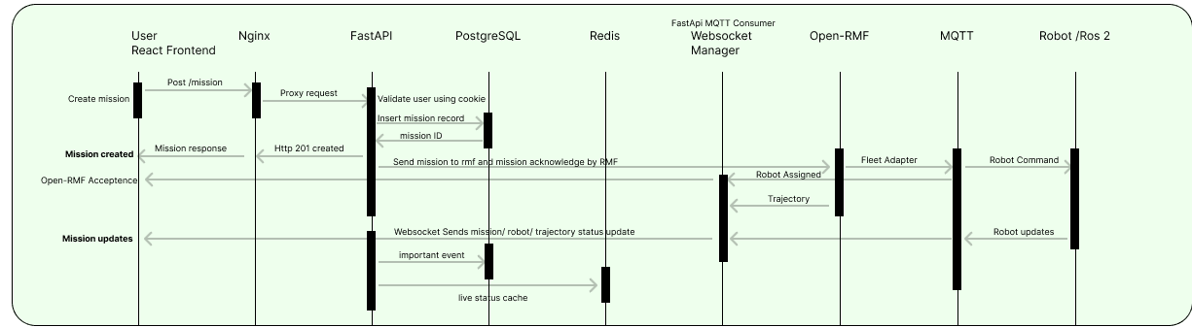
Robot telemetry processing
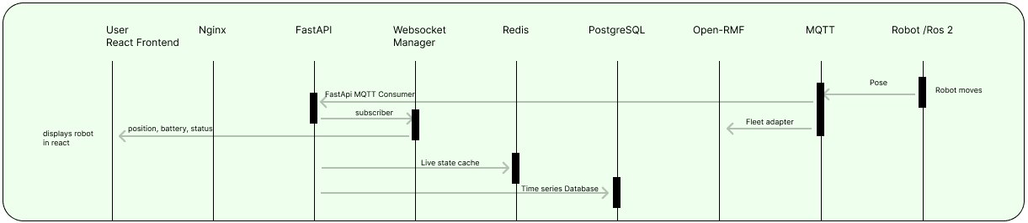

keep a websocket manager in fast api that keeps the track of the users current page. when a data receives, it checks the list of user who subscribed to it and send the data only to that user. this avoids dumping all the data to all the user.

Fleet Adapter talks in the language of RMF and a robot fleet. How does R01 participate in RMF?.
Robot Gateway talks in the language of MQTT and an individual robot's ROS 2 system.

facility navigation graph. That is what people usually mean when they say you need to "define the path beforehand."
rmf traffic editor, waypoint lane , rmf navigation graph
when two robot need same path, The RMF core provides task queuing and conflict-free resource scheduling, while fleet adapters connect that coordination layer to actual fleets.
RMF's RobotUpdateHandle explicitly provides mechanisms for updating a robot's position and requesting replanning; the API can report waypoint/orientation or position/lane information.

The MQTT bridge/fleet adapter integration is something you implement/configure for your system; MQTT is not the native transport inside Open-RMF. Open-RMF's native ecosystem is ROS 2, with defined interfaces between RMF and fleet integrations
he RMF API explicitly supports position updates and replanning.
Open-RMF's Traffic Editor is used to annotate a floor plan and create traffic patterns, and RMF tooling can generate navigation graph files from the building map.
The RMF fleet adapter API itself also supports defining graphs, adding waypoints and lanes, holding/pass-through points, etc.

for batch store to postgre if the fastapi crashes then those datas are lost.
solution-> Use MQTT QoS + persistent broker/session configuration + durable processing strategy
will querying one year's telemertry be fast-> PostgreSQL supports partitioning, and partition pruning can substantially reduce the amount of data that needs to be scanned when queries include the partition key.
give me all telemetry for r01 during mission 123-> indexes like (robot id, event time)

Facility/navigation graph
Defines:
- waypoints
- lanes
- floors
- docking points
- charging locations
- pickup/drop-off locations
- holding/pass-through points
- other facility-specific annotations

Robot/fleet configuration
Defines things such as:
- robot profile
- footprint
- vehicle characteristics
- battery characteristics
- fleet
- robot starting locations

Task management
Things like:
delivery
loop/patrol
cleaning
docking
charging

The Open-RMF project provides rmf_traffic_editor and rmf_building_map_tools. The Traffic Editor is the GUI for annotating a floor plan and creating traffic patterns; the building-map tools then convert that building description into things such as a Gazebo world and RMF navigation graph.
MQTT has concepts such as persistent sessions and queued messages, depending on MQTT version/client/session configuration.
for mqtt we have to configure
- QoS
- session behavior
- persistence
- message expiry where appropriate
- broker storage

The Fleet Adapter also tells RMF things such as:
- current robot position
- battery state
- task progress
- delays
- interruptions
- navigation progress
- docking/charging information

RMF can reason about:
- robot locations
- traffic conflicts
- shared corridors
- intersections
- doors
- lifts
- charging
- tasks
- fleet coordination
- planned trajectories

nav2 deals with
- localization
- costmaps
- planners
- controllers
- obstacle avoidance
- sensor data

fastapi usecase:
User login User roles Mission creation Mission history Audit logs Analytics Robot dashboard Reports Notifications Map APIs WebSocket connections
RMF handles:
Fleet coordination
Traffic
Robot task coordination
Robot trajectories

FastAPI | Open-RMF
Authentication | Fleet coordination
User roles | Traffic coordination
Missions from UI | Robot task execution
Audit | Robot trajectories
Analytics | Fleet state
REST APIs | RMF task system
WebSockets | RMF traffic system
Hospital business logic | Robot coordination

Traffic Editor creates the facility representation. RMF uses that representation for fleet coordination. Fleet Adapter connects RMF to your robots. MQTT transports messages. Robot Gateway translates MQTT to ROS 2. Nav2 moves an individual robot. FastAPI runs the hospital application. Redis provides current state. PostgreSQL stores durable history. WebSocket delivers live information to React.

There are also other planner plugins, including approaches such as:
NavFn
Smac planners
Theta*
etc.

Nav2 Jazzy documentation lists controllers including:
DWB
TEB
Regulated Pure Pursuit
MPPI
Rotation Shim
Graceful
Vector Pursuit

Which Nav2 planner/controller should you use?
For your hospital AMR simulation, don't immediately try to optimize everything.
I'd start with:
Global planner:
NavFn or appropriate Smac planner
Controller:
Regulated Pure Pursuit
or DWB initially
The choice ultimately depends on your robot's:
- drivetrain
- footprint
- speed
- turning constraints
- corridor width
- expected obstacle behavior
For a differential-drive hospital AMR, Regulated Pure Pursuit or MPPI are worth evaluating for path following; DWB is also a straightforward starting point. Nav2's documentation specifically describes DWB for dynamic obstacle avoidance, RPP for exact path following, and MPPI as a predictive MPC controller.
I would not call one universally "best" without your robot's kinematics and performance requirements.
NavFn + RPP, get the whole RMF → robot → telemetry → dashboard pipeline working, and only tune/change the navigation algorithms if the simulation shows a real problem.
QOS -> quality of service
qos 1, qos 0, qos 2
why each component exists
data flow- mission creation and acceptance, robot state, map datas,
bd and bd modeling, timeseries with partitioning. indexes
caching-why systems use Redis or other caches.problems in cache- cache invalidation, state data, ttl,cache eviction, cache consistency.
Messaging and Event-Driven Systems - > learn - message queues , pub/sub, event-driven architecture,mqtt, kafka, rabbitmq, redis pb/sub, message acknowledgment, retry, dulicate msg, ordering, delivrey guarantees.
lear http, websocket, sse, mqqt, ros2/dds
scalability-> What happens if the system becomes 10× bigger? learn-> horizontal scaling, vertical, load balancing, stateless service, db scaling, caching, message brokers, sharding, replication,
reliability and fault tolerance -> What happens when something breaks? -> robot disconnects, backend craches, bd becomes unavailable, mqtt broker restarts, network disconnects, websocket disconnects, redis craches.
security-> authentication, authorization, session, jwt, cokkies, oauth, rbc, tls/https, passwod hashing, encryption, rate limiting, csrf, cors, input validation, audit logging, secrets management.
observation-> logs, metrics (cpu-60%, websoc con-25, mis success rate - 90%), traces
deployment and infrastructure - > linux, process, continer, docker, docker compose, kubernate, reverse proxy, dns, tls, load balancers, ci/cd, networking, cloud vs on-prem.
consistency and distributed system -> Once multiple services exist, things become more complicated. learn -> strong vs eventual consisency, distributed transaction, race sondition, idempotency, concurrency, ordering distributed locks, leader election cap theorem.
trade-offs-> This is probably the most important system-design skill. Why this instead of that?-> websocket vs sse, redis vs postgresql,
api, data - database, messaging - events, preformance, sclability, reliability, security, observability - deployment - failrue / recovery
mental model for system design
who? -> who is communicating?
what? -> what information /commands are being exchanged?
how? -> which interface/protocol ?
transport? -> TCP or UDP?
where? -> which service receives it?
what if it failed? -> retry? reconnect? queue? ignore?
for this project
who? -> user- react dashboard- fastAPI
what? -> "start mission 1234"
how? -> https rest api
transport -> tcp
reliability and failure handling -> network failure, service crsah, robot disconnect, db fail, websocket disconnect, mqtt fail retry/reconnect, recovery, idempotency
security-> authent,autho, rabc, jwt/session, tls, pass hash, rate limiting, audit logs,
scalability and performance-> load bala,hori verti scaling, caching, db scaling, message broker, connection management, bottle necks,
dep
observability
system design artifact/diagram -> use case dia, architecture, data-flow dia, seq dia, er/db dia, dep dia
what goes into into postgresql-> users, roles, robots, mission, mission_events, audit logs, incidents, facilities, charging stations
redis-> latest robot state, websoc connection/session information, temp state, caching, rate limiting, pub/sub, short-lived data
why mqtt?
one telemetry data needs to be consumed by RMF, backend, logging. if we use http we have to send this to every service and for all users and for websocket we have implement how the message transfered have to be consumed. but this broker acts as pub/sub and can be consumed by multiple service and one msg can reach multiple subscriber, robot doesnt need to know who consumes the data, provides different delivery guarantees (mqqt), persistent session. topic based organization.

rest api -> request-> response operation like -> create mission, get mission history, login, get reports, update user
websocket -> continuous real-time update -> robot moved, robot battery changde, mission, status changde, robot disconnectde.
constraint-> constraint is a limitation or rule that restricts your design choices.
deployment cons-> system must operate within hospitals local network-> no dependency on public cloud for core operations
technology constraint-> backend must use fast api, robot coordination must use openrmf, messaging must use mqtt
environment con-> system must operate on hospital infrastructure
security cons-> patient/mission info must not be exposed publicly
how to store-> users,robot,mission, mission history, audit logs, incident, facilities, configuration, robot telemetry
why fast api -> suer login, user roles, mission creation, mission history, audit logs, analytics, robot dashboard, reports, notification, map apis, websocket connections.
rmf handles-> fleet coordination, traffic, robot task coordination, robot trajectories
what is traffic editor-> used to create the facility map/navigation representation for RMF. for walls, rooms, cooridorss, waypoint, lanes, doors, lifts, charging areas.
rmf needs -> robot id, position, orientation, battery, trajectory,
why redis-> current state.'
What if FastAPI crashes before telemetry reaches PostgreSQL? -> those records can be lost.
For important data you need a durability strategy involving things such as: mqtt qos, persistent broker/ session configuration, durable procesing, appropriate db constraints.
What happens with duplicate MQTT messages? -> suppose cmd-123 is delivered twice. your applicaton should be idempotent-> store that id. possible mechanism -> unique db constraint, processed command tabel, redis deduplication, event id, command id
persistent MQTT broker/session configuration mean?-> It means the broker can persist relevant MQTT session/message state according to its configuration rather than relying solely on RAM. this matters if mosquitto restarts or a client disconnects and reconnects.
robot telemetry-> robot id, event time, receieved at, x,y,yaw, speed, batery, status,
events-> id, robot id, mission id, event time, event type, event data
postgresql partitioning -> instead of one enormous physical table: we partition it into telemetry 1,telemetry2
partition pruning-> Suppose your query is: WHERE event_time >= '2026-02-01'AND event_time < '2026-03-01'. PostgreSQL can recognize that January's partition cannot contain the requested rows.So instead of: January,February,March,April,May.it focus on feb alone.
What indexes should telemetry have?-> robot + time range-> (robot id, event time). other indexes depend on actual query patterns.
what if ROS/Gazebo crashes and the dashboard becomes blank? redis state and then new live mqtt state, distinguish live and last known state
what if ros2 crashes?-> no telemetry for a period, ur backend can mark, r1-stale/disconnected after a timeout. how I am handling it?
what happen if mqtt disconnect? -> maintain reconnect, disconnect, connected
what happens if fastapi restarts?-> postgreesql - durable mission state and redis - rebuild/cache current state. aft restart
what if jwt expires while websocket is open? -> close connection ask to login again ( re-authenticates )
websocket manager in fastapi-> responsible for websocket connection and subscription of which user uses which page.
What happens when the user changes pages?-> in fleet dashboard page so he subscribes fleet_state the user open audit page unsubscribe fleet state and subscribe audit events.
Fastapi consumre-> gets message from mosquitto and decodes it and sends it to redis, websocket manager, postgre sql
what if a human blocks a corridor? -> robot 1 - sensor - nav2/local obstacle handling
what if 2 robot want the same corridor ?-> RMF's traffic coordination system can reason about planned trajectories and shared facility resources.
What if R01 completely disconnects?-> fleet adapter -> no state update -> robot considered stale/offline according to policy. display last seen
what if mosquito craches -> reconnect, broker restart, persistent broker confguration, client retry/backoff, system health monitoring. the robot should store the data on the ros2 side and upon reconnection it should send it and store it?
what if rmf craches? -> reconnect restart the mission that stored in the redis or postgre should fill the rmf with same priority and queue.
what if fastapi craches but rmf is still running?->fleet layer can potentially continue independently, some of the telemetry data might be lost , the commands from frontend might have also not be accepted.
what if frontend loses connection? -> detect disconnect, reconnect, retrive latest datat then consume live data. if jwt error or expire user might need to login again
data flow for deliver medicin-> react -post/mission - fastapi- mission to postgresql - fastapi -rmf - fleet adapter- mqtt- mosquitto - ros2/nav2 - ros2 send report - mqtt- mosquitto - fleet adapter - rmf- mosquitto - fastapi consumer- redis, postgresql, websocket manager - react.
RMF source expose -> rmf fleet adapter, fleet update handle, robot update handle, easy full control( provides callbacks and robot-state update functionality )
use traffic editor before building own editor -> phase 1 learn traffic editor, phase 2 generate equivalent rmf data.
what is rmf graph-> facility's defined navigation network. waypoint and lanes. shared road/netwrk structure on which rmf calculate plan
trajectories -> particular robot's planned trip through that network by rmf
why building map tool -> gazebo needs .world, modelc,etc and rmf needs graph, waypoint.so one source-. multiple generated outputs.
what happens after restarting rmf?-> restart-> load hospital navigation graph-> recreate runtime rmf graph object-> continue.
nav- localization-> costmap-> global planner-> path-> controller-> vel-> robot.
planner-> What path should the robot take to get from here to the goal?
controller-> How should the robot physically follow this path right now?
available planner-> navfn, smac planner, theta*
available controller-> dwb, teb, regulated pure pursuit, mppi, rotation shim, gracefu, vector pursuit
using default-> controller- regulated pure pursuit and planner - navfn.
how rmf grph fit relative to nav2 planner-> rmf-facility level plan-fleet adapter- nav2 goal- nav2 goal planner-ocal robot path- controller-robot
why fastapi-> authentication, mission management, hospital business logic, db access, audit, analytics, restapi, websocket, mqtt integration.
mosquitto in production-> Mosquitto would normally run as a managed service/container rather than being manually started in a terminal.
How does the JWT/WebSocket reconnection work when JWT expires?-> serer closes websocket Your frontend should not blindly reconnect forever.it should distinguish: network failure from authentication failre.
after reconnection Don't assume the old server-side WebSocket connection still exists. the frontend should restore them by send again the subscription required.
frontend show-> static facilit map- building/floor layout , navigation network-waypoint=+lanes, dynamic robot info- robo pos, trajectory, actual movement, mission.
phase to build-> frontend, facility using map editor, robt-ros2-nav2, rmf-fleet adapter, mqtt, test connection rrmf - robot and viseversa, hospital backend, web map editor.
store rmf nav graph in configuration map artifct along side simulation files. store meta data like map id, name, floor, version, fiel path, created at in postgre sql
we can implement fleet adapter in a way to send imediate goal and next part can be commanded or sending whole goal at a time.
What if the robot deviates from the RMF path?-> 2 kinds-> small local deviation, robot significantly leaves the rmf route in this case the rmf replan .
what is gateway?-> Gateway is generally a software integration layer for a robot type/vendor/protocol, not necessarily one Gateway process per physical robot.
rpp= Regulated Pure Pursuit. It is a Nav2 controller. The planner decides the path. RPP decides how the robot should drive along that path. this calulates things such as -> How fast should I move?, Should I turn left/right?, How much should I slow down for a turn?, What velocity should I send to the robot?. produce velocity commands. y it is called pure pursuit-> Imagine a person walking along a curved road. Instead of staring only at their feet, they look a little ahead along the path and steer toward that point."Regulated" means it adds speed regulation rather than blindly following the path at maximum speed—for example, reducing speed in situations where slowing down is appropriate.
find what the robot interface provide like robot sate, naviagetion api like send goal, cancel goal, get pose, get battery.
define your mqtt interface-> robot/id/command/navigate their own pub/sub
sub to mqtt->sub that in the robot side
convert mqtt cmds into ros2 cmds
listen to ros2 robot state.
fleet adapter consumes robot state
FastAPI can independently consume robot data
Handle commands carefully like use cmds id.
rmf-> RMF is the traffic and fleet coordination layer. It decides which robot should do a task, where that robot should go through the shared facility, and coordinates multiple robots so they don't interfere with each other. task, fleet management, traffic coordination, navigation graph, robot state, task planning,
one flow for one medicine delivery-> nurse creates mission- react-post/mission- fastapi-rmf-rmf looks at facility graph, robot status, fleet state, existing traffic, task req- rmf plan route/trajectory- fleet adapter- mqtt cmd- mosquitto-ros2/nav2 - nav2 handles global/local navigaation, obstacle, path following, velocity cmds- robot moves- robot sends data-ros2-mqtt-rmf(fleet adapter-rmf), fastapi receives it(redis, postgre,websocket)
fleet adapter-> A Fleet Adapter is the translator/bridge between Open-RMF's fleet-level world and the actual robot fleet. this receives rmf comds, convert rmf to robot cmds, receive robot state, update rmf with robotstate.
what is hospital floor plan? -> A floor plan is the drawing/representation of the physical hospital floor. it can be architectural cad drawing, hospital blurprint, floor plan image, manually drawn map, anothre digital facility map,
building.yaml-> structured RMF building description created/edited through Traffic Editor.
rmf graph-> generated from the building YAML and loaded by RMF at runtime.
gazebo world-> generated from the building YAML and used by Gazebo to simulate the physical environment.
nav2 map-> a separate occupancy-grid map. It can be prepared beforehand; it does not have to come from SLAM.
slam->builds a map + localizes the robot.
amcl-> uses an existing map + sensor/odometry data to localize the robot.
rose pose-> should ideally be the localized/estimated pose from your ROS2 navigation stack for realistic simulation, rather than simply using Gazebo's ground-truth pose.
frontend-> should receive static map + robot state + RMF trajectory separately, then combine them visually. It should not receive the entire Gazebo world and render Gazebo itself.
user leaves the page open and jwt expires-> client side session timer taken from the backend (take expiration info and store it int eh local storage and show ur session is about to expire ) and backend must enforce expiration with redis (websocket manager should remove connection and send 401 unauthorized and redirect to login page)
how?-> on auth when we find no data we should handle it.
on jwt expire -> when get /app auth/ session happen when loading react jwt expired and return 401 unauthorized then we set cookie : jwt=; max-age=0 react then does not open websocket and redirect to login
mission db-> id, created by, robot id, pickup, destination, status, created at, started at, completed at, failure reason
before assigning the mission the rmf looks at battery, current robot position, facility graph, traffic, task requirement, battery model. it also helps in montior door, lifts
when charge is low while doing a task ->RMF's task planning can account for battery/resource constraints and insert a recharge task into the robot's itinerary when needed
localization-> where am I
planner-> what path should I take? ->Nav2's Planner Server receives a goal and uses a configured planner plugin to compute a path; it also hosts the global costmap.
Controller — "How do I physically follow the path?"
while connecting the open rmf ->The official EasyFullControl API, for example, expects you to add robots, provide their state, and implement navigation/stop/localization callbacks. For your simulation, you will configure things such as:hospital RMF navigation graph, fleet configuration, robot names, robot initial, position, vehicle characteristics, battery parameter, charger location, navigaiton callbaks, robot state updates, ur mqtt integration/gateway , how rmf navigation cmds reach nav2.
login audit-> db0> user if, login time, logout time, ip/device info
if http is coneected/working but websocket connection is not it should not logout user.
how to know which is disconnected?-> case 1 -> robot is disconnected-> Use a robot heartbeat/state timestamp.
case 2->gateway losses mqt-> monitor gateway mqtt connection and and MQTT connection state / broker logs / last-seen timestamps.
case 3-> mosquitto crashes-> Your MQTT clients should detect the broker connection loss and reconnect.
case4-> rmf flet adapter crashes-> fastapi receive robot state your health dashboard should distinguish this.
case5-> fastapi mqtt consumer crashes->FastAPI may stop receiving live robot data.
Therefore don't have one status called "Robot Connected"-> robot heartbeat, ros2//gateway, mqtt connection, rmf adapter, fastapi, websocket
map changing process->Don't change a waypoint underneath a robot that is currently using it without a controlled migration procedure.
stateless jwt-> When the user logs in, FastAPI creates and signs a JWT.
The browser stores it in an HttpOnly cookie.FastAPI can perform these checks using the token itself and its signing key, without retrieving a session record from Redis for every request.The JWT contains the necessary claims, such as the user's identifier and expiration time.
PostgreSQL can still store user accounts, roles, and other application data. Stateless authentication does not mean your entire application is stateless.
stateful session auth->holding the value in session.The backend looks up the session to determine whether it is valid.
You can also use JWTs with server-side session records. In that case, the JWT itself is stateless in format, but your authentication system uses additional server-side state.
A deliberate revocation/session strategy if immediate account deactivation is required.
FastAPI dependencies for authentication and authorization.
One security detail: if your frontend uses cookies for authentication, also configure appropriate CSRF protections for state-changing HTTP requests. WebSocket connections need appropriate Origin validation and authentication as well.
map data flow ros2-> the nav2 map server loads the map and publishes it in /map. this is ur static occupancy map. gazebo simulates robots sensor-Gazebo simulates a LiDAR sensor and publishes readings through ROS 2:-/scan and /odom.Gazebo produces the simulated sensor measurements; ROS 2 transports them to the navigation components. Nav2 uses the sensor data to update costmaps. The global costmap provides environmental information for global path planning.
It can use the static map and configured sensor layers.-> static/map+configured sensor layers -> global costmap+global planner+path towards direction.
local costmap represents nearby obstacles and is updated as the robot moves. lidar/scan+other configured sensor data->local costmap-> controller->velocity cmds
There are two key inputs:
- Static map: What is already known about the environment?
- Sensor observations: What obstacles are being detected now?
The costmap combines the configured inputs into an environmental representation for navigation.
A sensor observation does not automatically become a permanent change to the static map. The costmap is a separate, dynamically updated representation.
AMCL combines the known map with LiDAR observations and odometry information to estimate the robot's pose.
standard tf relationship is-> map-> odom-> baselink->laser...AMCL estimates the relationship between map and odom; odometry supplies the robot's motion estimate between odom and base_link.That localization information allows Nav2 to reason about where the robot is relative to the map and its navigation goal.
navigation loop-> nav2-> planner computes path-> controller follows path-> /cmd vel-> gazebo-> simulated movement-> /scan-> costmap->simulated movement-> /odom-> amcl->nav2 updates -> next control cycle
This is a simplified conceptual diagram: Nav2's planners, controllers, localization, and costmap components operate as separate ROS 2 components, exchanging topics, transforms, and actions.
httponly cookie-> store jwt securely in browser.

Deployment
Docker can automatically restart your hospital robot system's application containers if they stop or crash.
unless stopped poilicy - restart container unless we explicitly stopped it. we can create seperate container for each services in single compose.yaml.
if fastapi becomes unresponsive we can add a health check.FastAPI application would need to implement the /health endpoint.same goes for evrey service but we also need to show the connectoin status to the user
Docker restart policies do not protect against every failure. If the hospital server itself loses power, you also need reliable server startup configuration and appropriate operating-system and Docker daemon settings.
Docker Compose to deploy the system as multiple services, with each service responsible for a particular function.
mDNS is intended for local-link discovery. Wi-Fi client isolation, VLANs, and network segmentation can prevent devices from resolving or reaching one another. You must verify that the hospital network supports your intended setup.
deployment for multi robot touch screen
we build the touchscreen interface once, deploy it once, and open it on browser for all robots
create a react page which reads the robot id from the url using useParams().The React component stays the same. Only the robot ID changes.
How does the backend know which robot's data to return? -> fastapi uses get /api/robot/robot-1 .FastAPI identifies robot-1 and returns its information.
on production deployment the touch screen we deploy the same frontend on every robot and store the robot id in local configuration.
extras-> The system shall monitor the health and connectivity of critical services. Frontend applications shall display connection states and notify users when communication with the backend or robot is interrupted. Services shall implement appropriate reconnection and recovery mechanisms.
If FastAPI or Open-RMF restarts while a robot is delivering a payload, the system must reconcile the saved mission state with the robot's current state before deciding whether the mission can resume.
A restart policy alone does not provide this capability.
is persistent storage required?
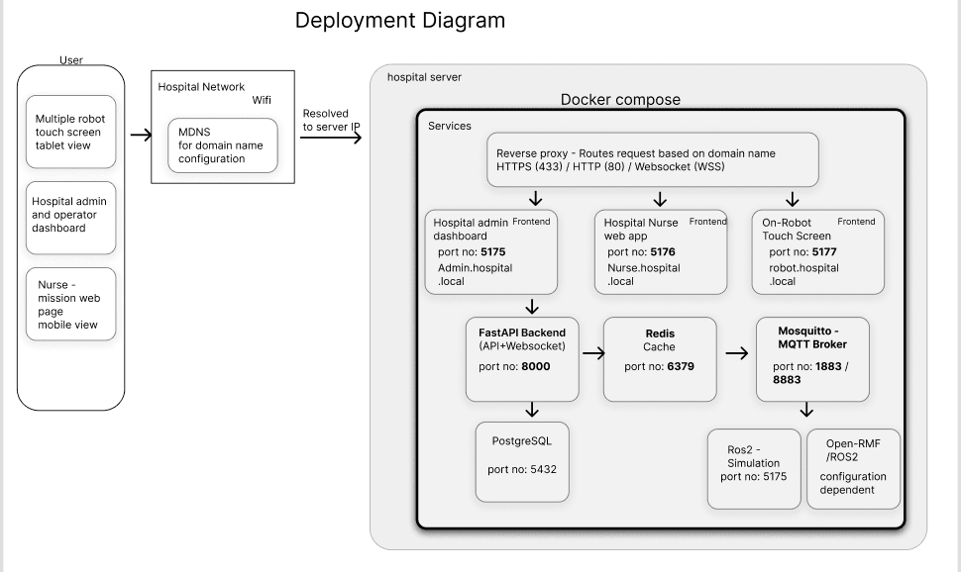
trade off of components.

